Jira integration added in existing configuration settings and connection validated
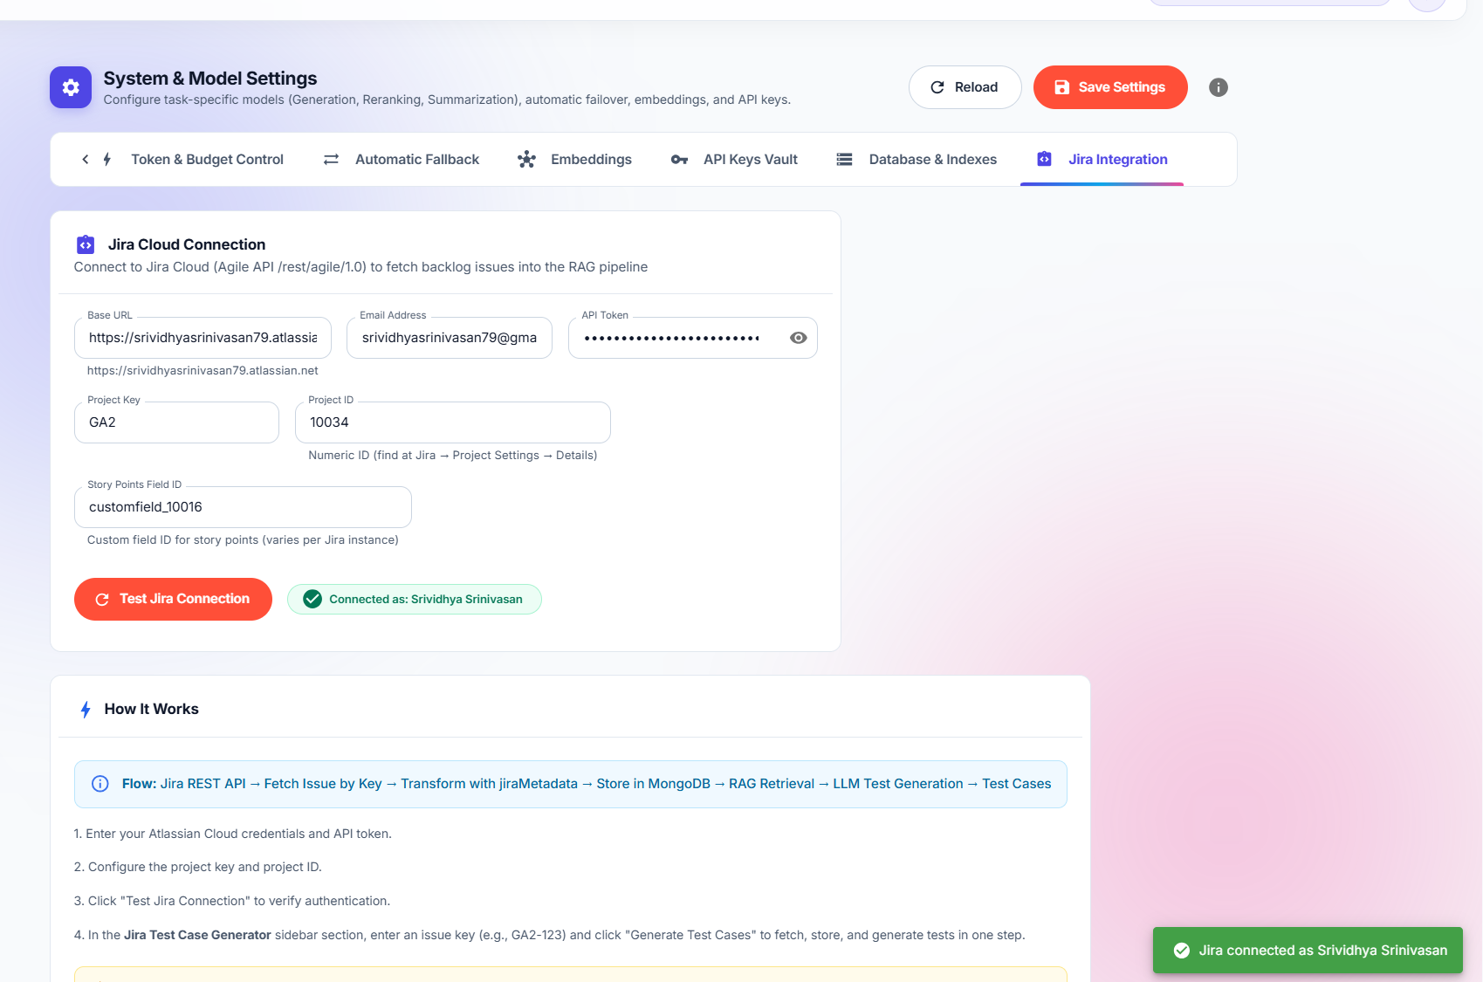
Added Jira Test case Generator in the existing UI
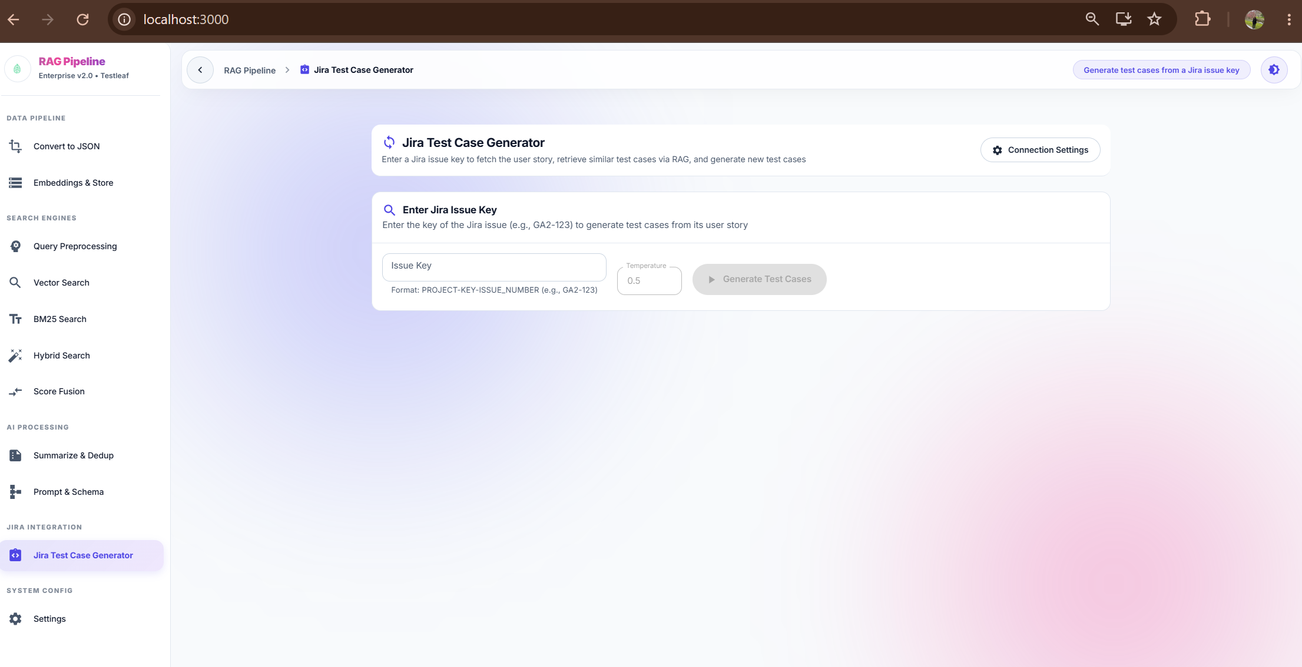

Test case generated by giving the PROJECT-KEY-ISSUE Number 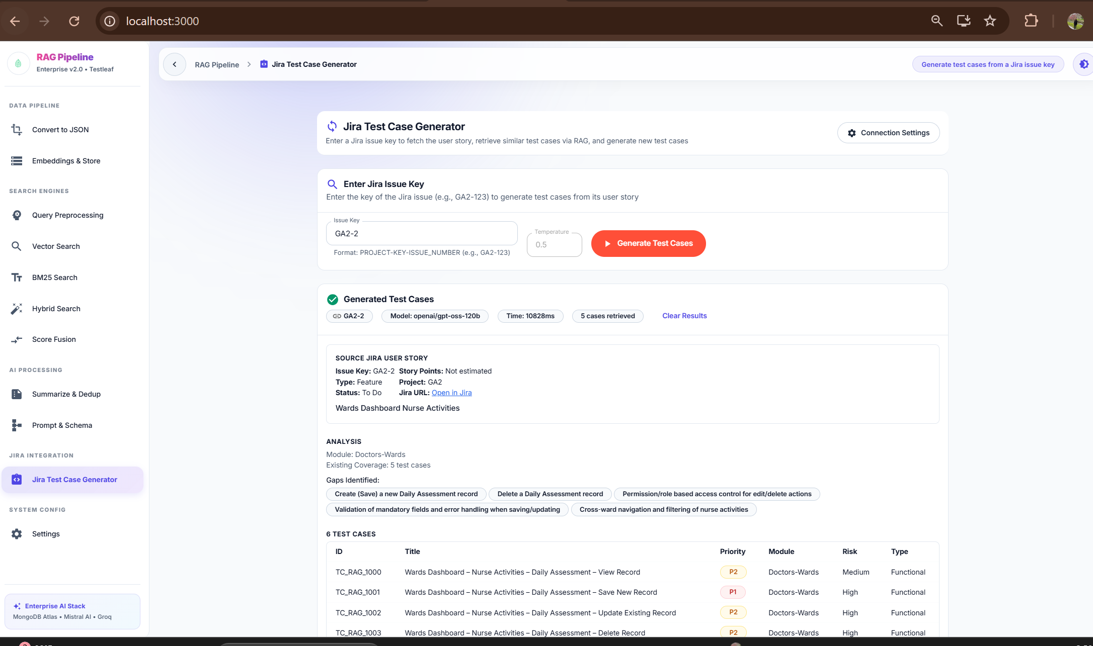

Jira URL link validated and userstory validated with JIRA. Jira URL link added for user story traceability.
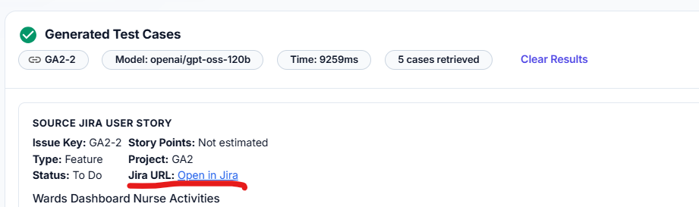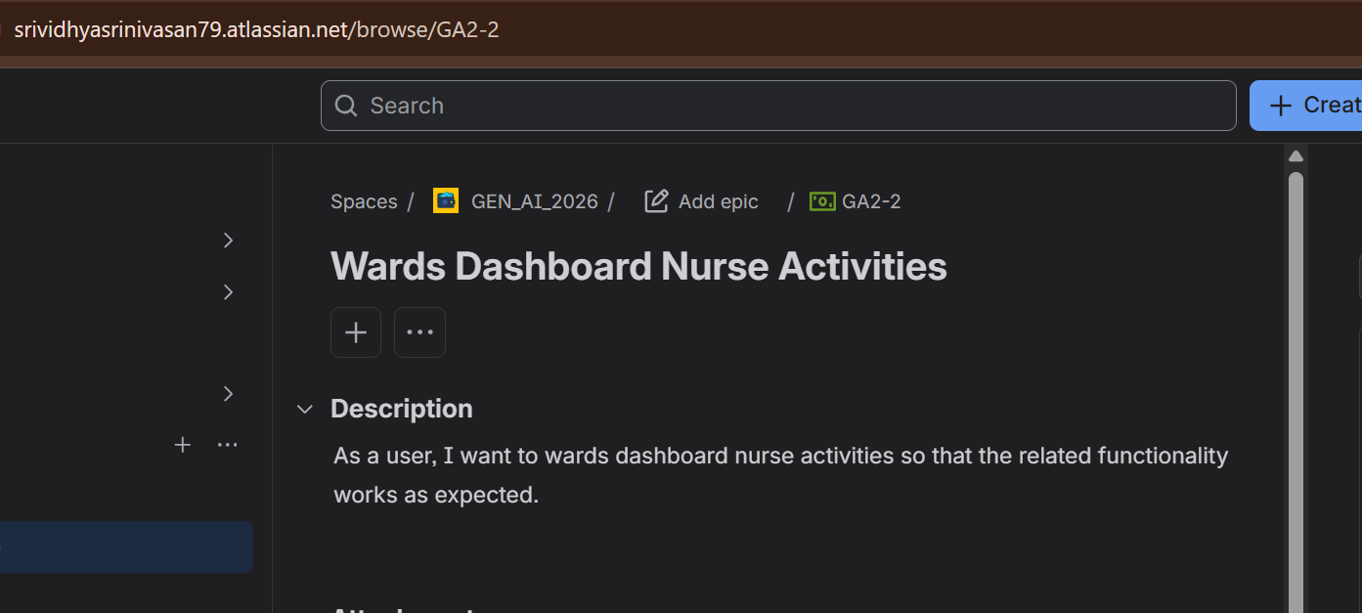
Clear Results Validated and generated test cases for another user story
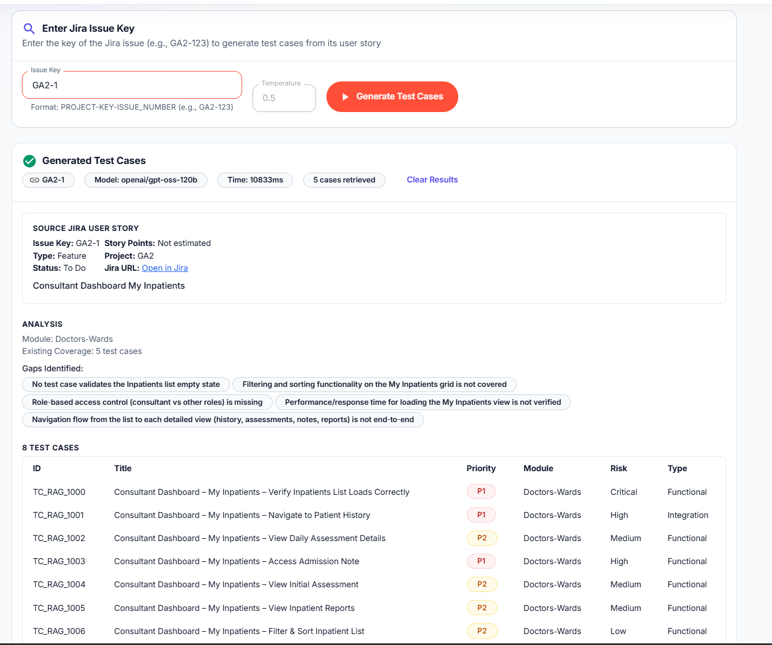
Continuation of UI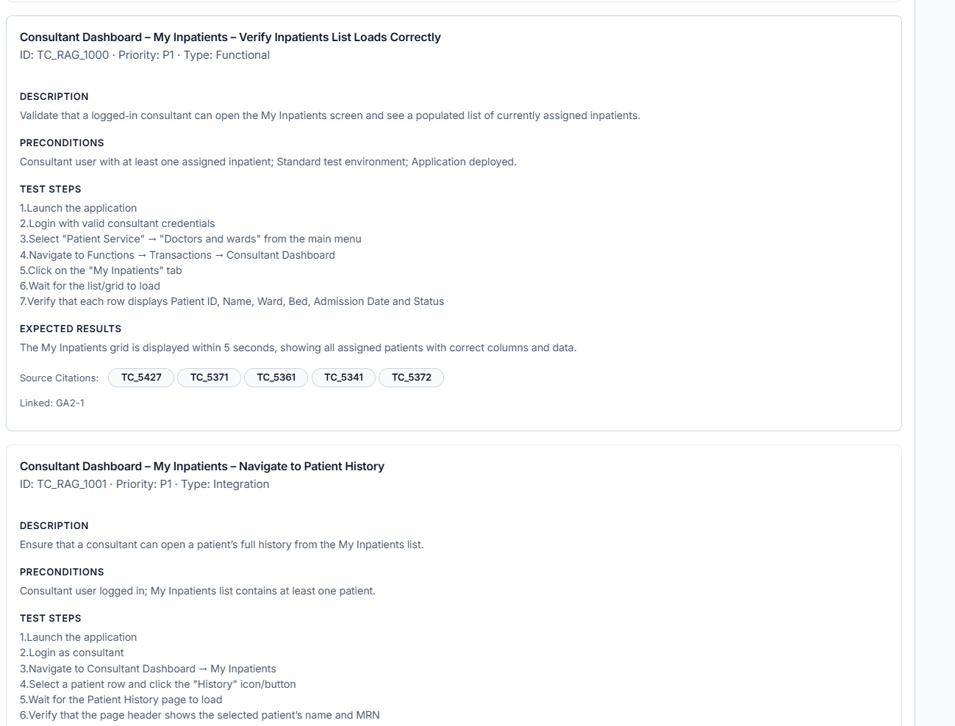
Challenges
- Understanding the requirement at the first instance. Took sometime to understand whether new collection/vector index is required for Jira integration. Attempted to understand with ChatGPT support to leverage the existing collection/vector index and use it for Jira integration.
Key learning- Separated integration from business logic - Jira should provide the input, not replace the existing AI/RAG functionality.
Jira ↓ Jira Integration ↓ Normalized User Story ↓ Existing MongoDB Ingestion ↓ Existing Retrieval ↓ Existing Test Case Generation

- Jira authentication returned 401 errors – After replacing new API key, the issue is resolved.
Key learning - Jira Cloud requires valid authentication. The Jira email, API token, and Jira base URL must be correctly configured in the backend environment variables.

- Blank page while clicking on Jira Test Case Generator option. Fixed with prompting. The root cause is process.env is not available in the browser. When the component renders, process.env.REACT_APP_JIRA_BASE_URL throws ReferenceError: process is not defined. Without an error boundary, React 19 unmounts the entire app tree — producing a completely blank page.

